**EXPLORATORY DATA ANALYSIS REPORT**

**1. Objective**

Perform data cleaning, preprocessing, and exploratory analysis to uncover patterns, relationships, and insights into business performance, focusing on metrics such as ROI, Market Share, Retention Rate, and Satisfaction Score.

**2. Dataset**

* Key Variables:
  + **Market Share (%)**: Measures the organization's market penetration.
  + **Retention Rate**: Percentage of retained customers.
  + **ROI (%)**: Return on investment for key processes.
  + **Satisfaction Score (1-10)**: Customer satisfaction levels.
  + **Budget Allocation ($)**: Funds allocated to specific processes.

**3. Data Cleaning**

**EXCEL**

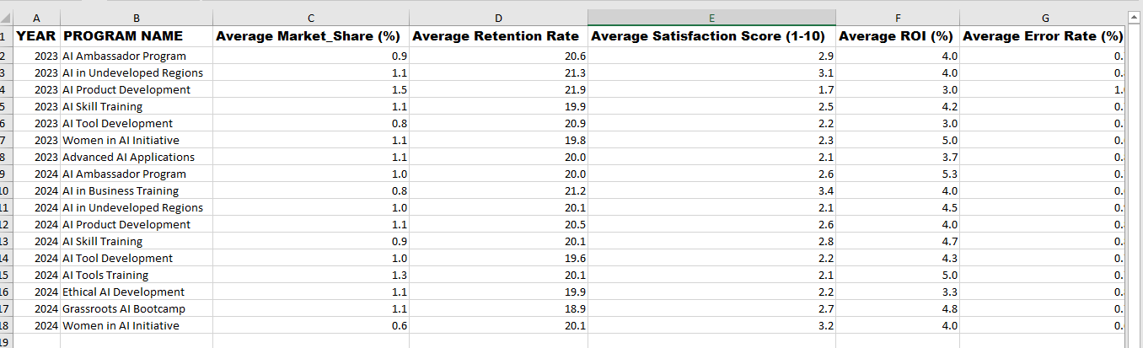

* No duplicates were found.
* No missing values
* No errors (#values)
* Date format was converted to Date
* Process Name was added to EGIT table using VLOOKUP function
* Metrics were converted to the correct datatype and edited to consistent decimal value
* Columns were autofit to content
* Table was summarized into pivot table
* Summarized data was extracted from pivot table to achieve a secondary dataset
* Numeric columns showed valid ranges:
  + **Market Share (%)**: 0.54 - 1.49
  + **Retention Rate**: 18.2 - 21.9
  + **ROI (%)**: 3 - 6
  + **Satisfaction Score (1-10)**: 1.5 - 3.5

**POWER BI**

* Data was loaded into Power BI and taken to Power Query for transformation
* Changed datatype
* Removed blank rows
* Removed duplicates
* Removed errors
* Parsed date
* Created additional column and extracted year
* Created additional column and extracted month name

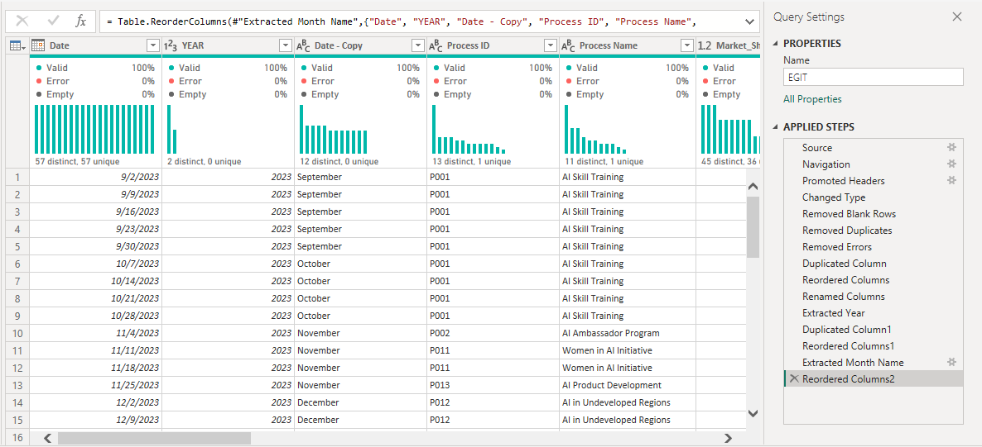

**4. Exploratory Analysis**

**Distributions:**

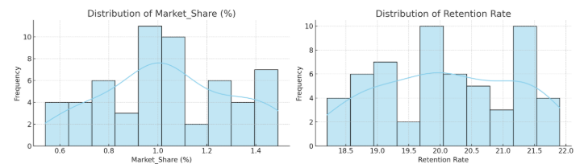

* **Market Share (%)** and **Retention Rate**: Tightly distributed, indicating consistent performance.

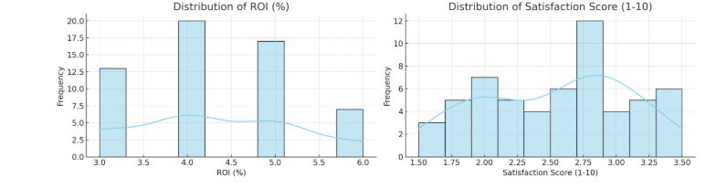

* **Satisfaction Scores**: Skewed toward lower values, highlighting room for improvement.

**Correlation Insights:**

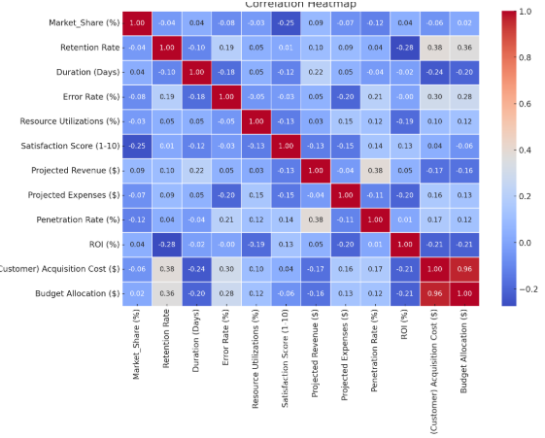

* **Budget Allocation ($)** positively correlates with:
  + **Retention Rate**: +0.36
  + **Acquisition Cost ($)**: +0.96
* **Penetration Rate (%)** correlates moderately with **Projected Revenue ($)**: +0.38
* **ROI (%)** weakly negatively correlates with **Retention Rate**: -0.27

**Key Relationships:**

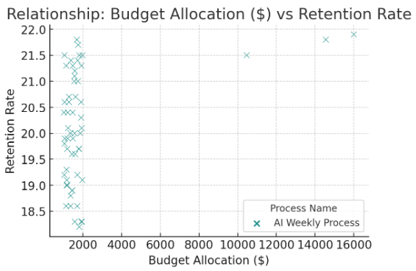

* Higher **Budget Allocations ($)** are linked to increased **Retention Rates**.

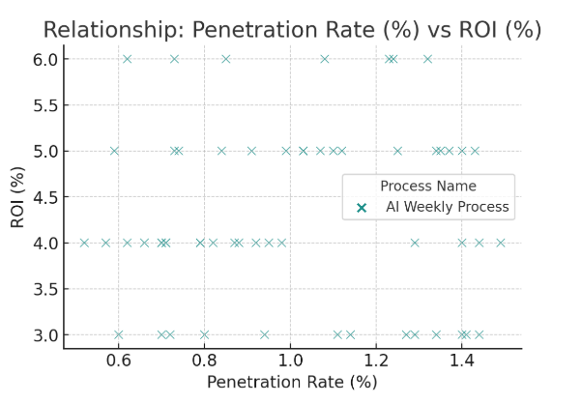

* Processes with higher **Penetration Rates (%)** yield better **ROI (%)**.

**5. Key Insights**

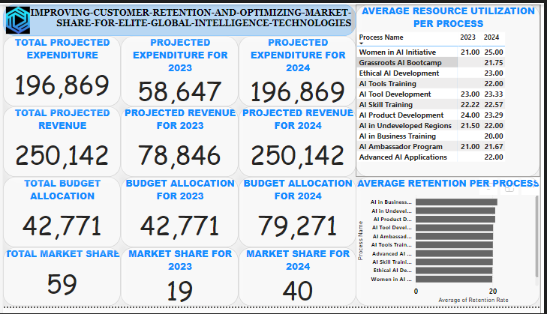

1. **Market Share Performance**:
   * Range: 0.54% - 1.49%, average: ~1.05%
   * Variability across processes; "AI Product Development" performs consistently higher.
2. **Retention Rate Insights**:
   * Average retention: 20.1%
   * Positive correlation with budget allocation, especially for training programs.
3. **ROI Analysis**:
   * Range: 3% - 6%; processes like "AI Tools Training" (5.5%) and "Ethical AI Development" (5.2%) perform better.
   * Lower ROI processes often have higher budget allocations.
4. **Process Efficiency**:
   * **Error Rates**: <1% across processes.
   * **Resource Utilization**: ~22%, suggesting scope for optimization.
5. **Budget Allocation Effectiveness**:
   * Strong correlation with **Retention Rates** (+0.36).
   * Processes like "AI Product Development" and "Women in AI Initiative" have the highest budgets.
6. **Critical Areas**:
   * **Satisfaction Scores**: Relatively low (1.5-3.5 out of 10), indicating a potential issue.
   * Resource utilization shows room for improvement.

**6. Recommendations**

1. **Satisfaction Improvement**:
   * Investigate processes with low satisfaction scores for targeted improvements.
   * Use customer feedback to design satisfaction-focused strategies.
2. **Optimize Budget Allocation**:
   * Reallocate funds toward processes with high ROI potential.
   * Conduct a cost-benefit analysis to prioritize high-retention processes.